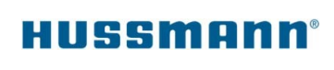

**REMITTANCE STATEMENT FORM_US ONLY**

The remittance statement form advises corporate finance where you would like your payments sent for OEM Warranty claim payments.

**If additional support is required regarding this form,**

**please contact the Hussmann finance department at: 314-291-2000**.

|  |  |
| --- | --- |
| **PROVIDER NAME:** |  |
| **PROVIDER CONTACT:** |  |
| **TELEPHONE (required):** |  |
| **E-MAIL (required)** |  |
| **REMIT TO ADDRESS:** |  |
|  |  |
|  |  |
|  |  |
|  |  |
| 11/21/2023 | rev.1 |